**Realizations: Realized at a faraway land ofSwitzerland**

*(Part-I )*

Just now, searched in the Google Maps, location Geneva, Switzerland, from Kolkata India. But to my utter disbelieve, the poor Google Maps could not calculate the distance between these two places!! Huhh… Mr. Pichai should take a note here! Then I directly Googled, “Kolkata to Geneva Distance”, now it says, 7632 Kms. Here you go!! But I guess it is more appropriate to call it ‘displacement’ rather than distance.

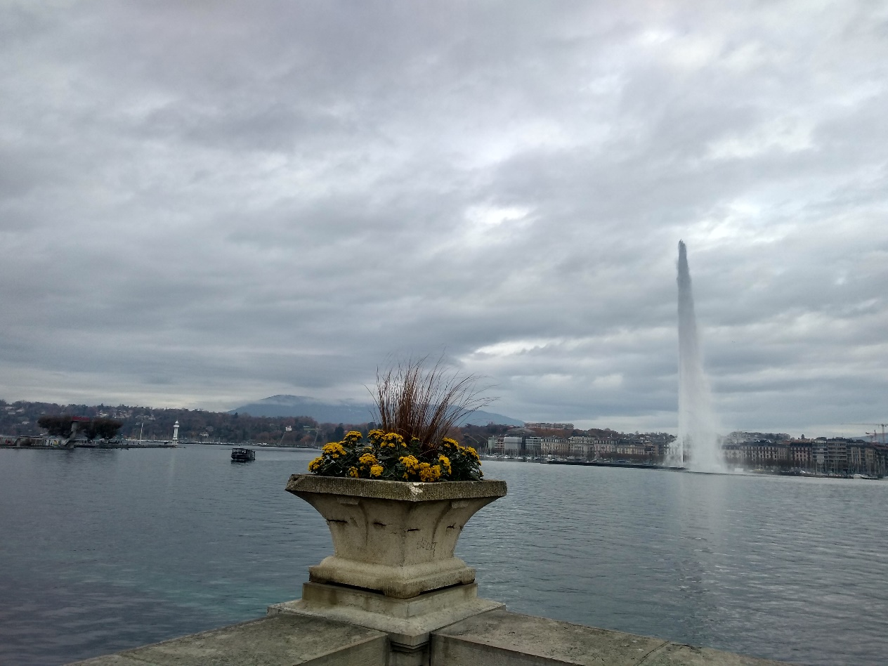

Lac Leman(it is what Geneva lake is called, lac means lake in French), Geneva, Switzerland, on a gloomy day in October 2017

Before the readers stop reading the article wondering, what is this crap about Google and distance and displacement; let me not fag you any further. Currently I am living, (better say, being displaced to), at this faraway land, Geneva, Switzerland. I am here for last eight and half months now, on a work assignment. As the numerical figure in the first paragraph substantiates my claim, it is indeed a far, faraway land for me.

You might think, oh wow!, Switzerland, how lucky she might be. Now that’s what I would say “perspective”. How you see things and how you let your mind believe in the things that you see (or sense). This is the 1st time for me (after I landed on Earth) to be staying outside my home, outside my Kolkata. Few days earlier, read in a blog, “Kolkata is not a place, but a feeling”. Yes it is. Kolkata is a feeling. Kolkata is where heart is. Kolkata is the place which is the abode of the people whom I love. Kolkata is a soul.

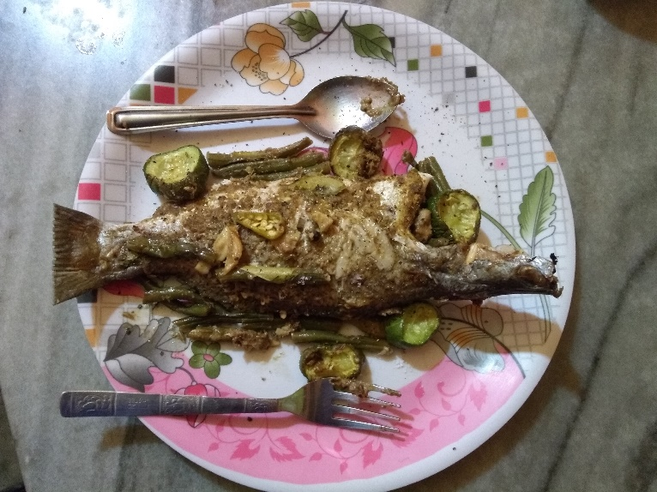

Grilled fish prepared by chef. My Husband, Kolkata. Miss home.

When I came to Geneva few months back, I was going through an emotional roller coaster, which I am kind of habituated with by now. As a country, Switzerland is really synonymous to ‘perfection’. It really is beautiful, and too much well ordered. The busses, trains, trams, and boats everything run on time. On time means “ON TIME”. It does not really wait for a second for anything. The lifestyle here is very well organized and predictable. Every day I realize new sensations. Does it mean that Switzerland is able to make me realize things which Kolkata could not instigate?! No, that’s not the case. In the Bengali movie,“Shubho Mahurat”, one of the leading protagonist once said ‘Your observational skills amplify when you are alone.’ So here I am, Alone! Observing, realizing and contemplating every small detail as possible.

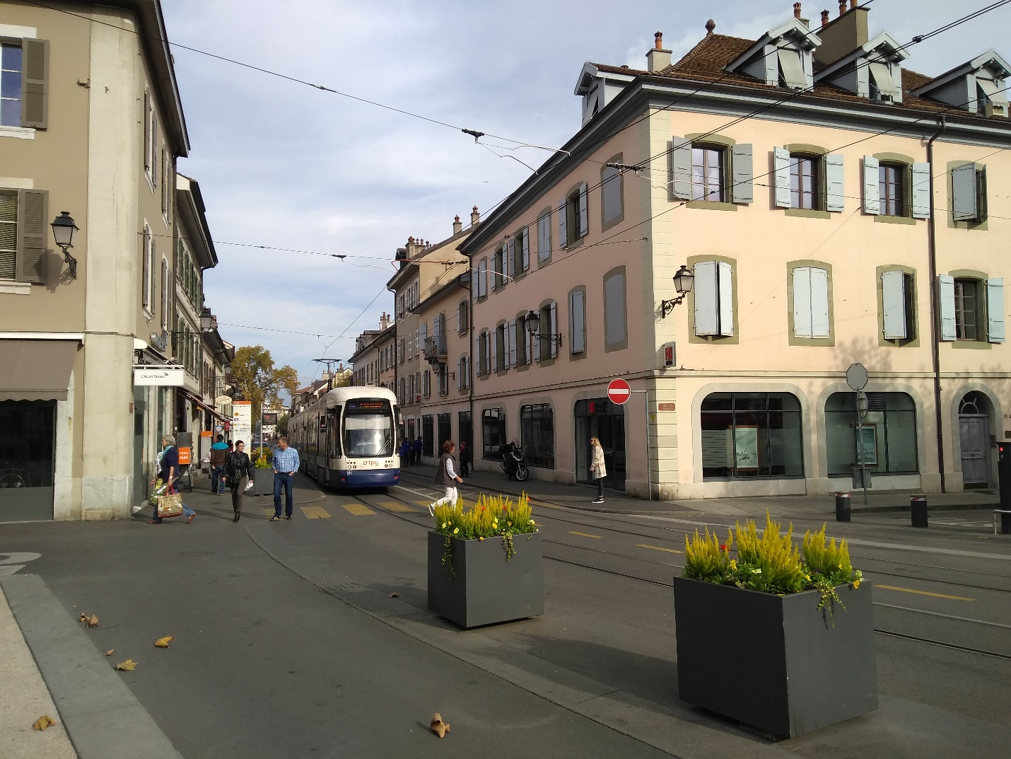

Tram in Geneva, Switzerland.

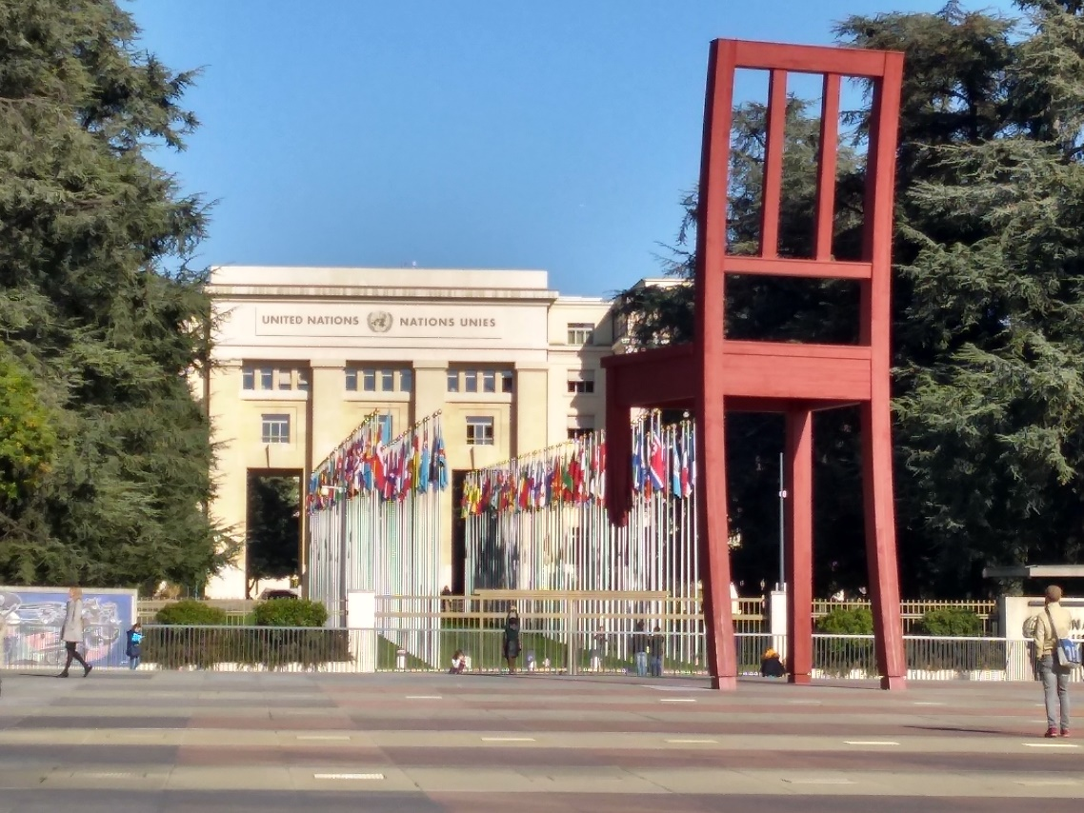

The symbolic Broken Chair, in front of United Nations headquarters, Geneva, Switzerland

When I landed here, I took a cab from the Geneva airport. The old man driving the cab helped me with all my luggage, and was chatting with me on my way to the hotel. After more than 30 hours of reaching my hotel, I realized that I had forgotten my jacket in that cab. I was pretty upset on my stupidity and my immense capability to do something wrong every time. It was the only ‘warm’ jacket that was meant to comfort me from the Swiss chilly winter. Anyways, nothing I could do then. Just thought to inform the hotel reception once about the loss, and if they could help me find it. That night, I was absolutely amazed when I received a call from the hotel reception conveying that the kind hearted cab driver came to return my jacket. Oh really, I never thought this kind events could happen in the world even in 2018??!!

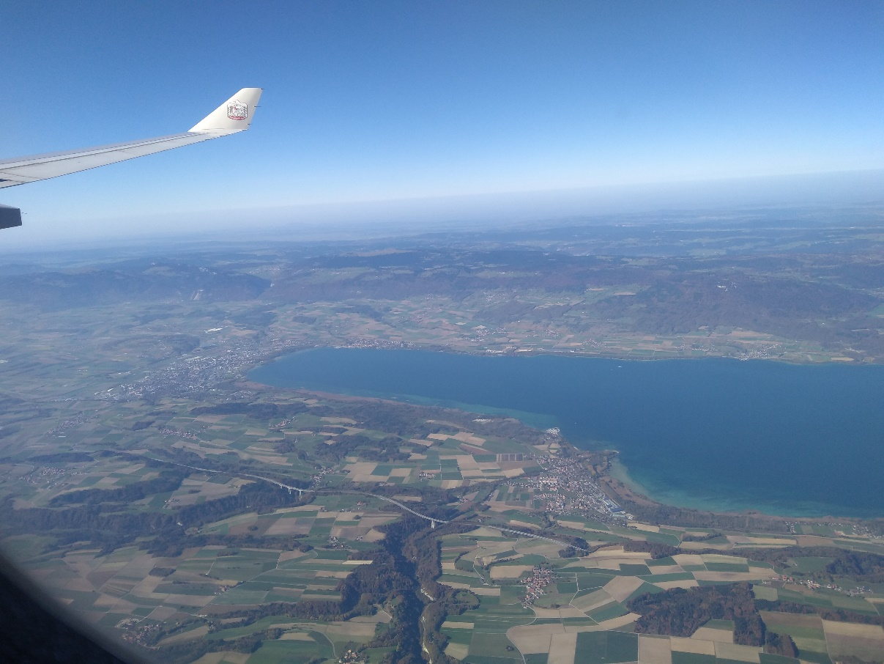

Aerial view of Lake Leman, before touchdown at Geneva Airport

There is a general inclination of human to opt for the roads he is used to travel, to do the things in the way he has done before. I guess this is us, just trying hard to be away from the “changes” as far as possible. But as they say, change is the only constant.

Back in Kolkata, even if I had to fight (like the gladiator) my way to board the local train or even if I had to stand in the queue of bank counter for 2-3 hours of despair; the woes never knocked me off. As I was used to those occurrences, I never felt out of place amidst of all the chaos. (Now my friends, even chaos has a definite pattern of its own – Nerd Alert, Duh!). When I came to Geneva, the Airbnb house, where I was staying for the 1st two weeks, was a bit far from my workplace. I Googled the route from that place to my office, and I used to follow exactly the same route every day, as Mr. Google depicted as the best one. I did not even dare to look if there are any other possible available routes.

Then one weekend I visited the local farmer’s market. On my way to the farmers market, I had realized that there exists an even more simple and easy way to my office rather than the one that I took for past seven days. It made me realize that you have to move out of your comfort zone, even if you are scared. You have to take the first few steps. It is then, that the fear of the unknown starts to fade away and you start realizing new possibilities, new avenues. Am I sounding too philosophical??!! If yes, then I apologize. From here on I will try not to be one. Rather, let us talk about something sweet indeed.

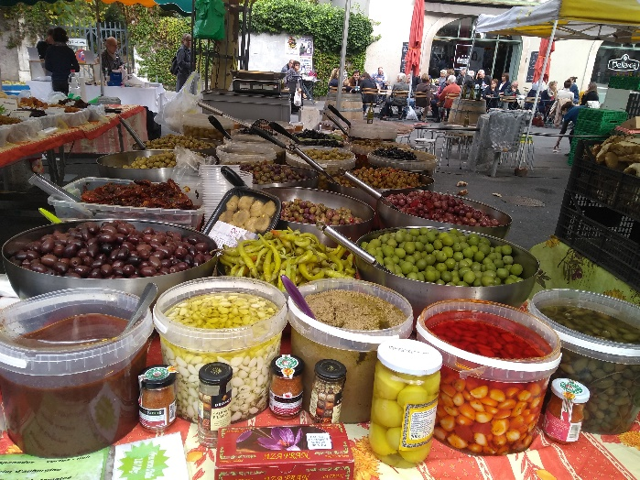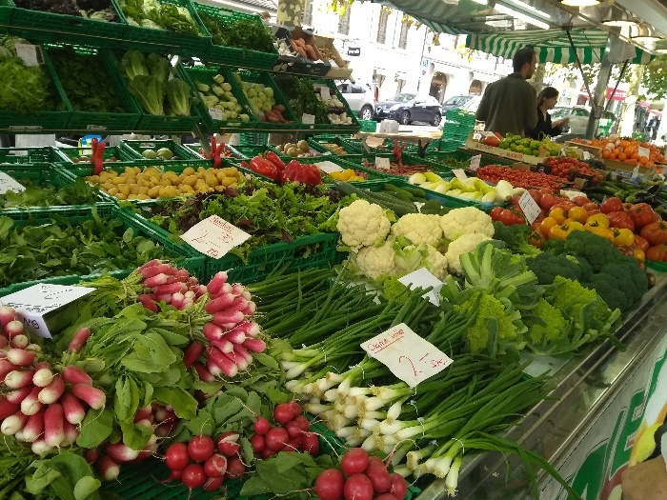

A local farmers’ market in Geneva

Swiss chocolates and Swiss banks are world famous, right?! Yes, sure I would share my experience about both. Swiss chocolates, OH yes; no other chocolate can even dare to complete. Its pure bliss. The Swiss chocolates are life saver to me. When I missed all the sweets back home on the day of Saraswati puja, and could not think of what to offer to my little ‘Saraswati’ (on my desk) , the Swiss chocolates came for the rescue. Believe me, when I felt too depressed to even talk to my neighbor (cubicle) at the office, the Swiss chocolates lifted me up. Now let’s take a look into the Suisse banks.

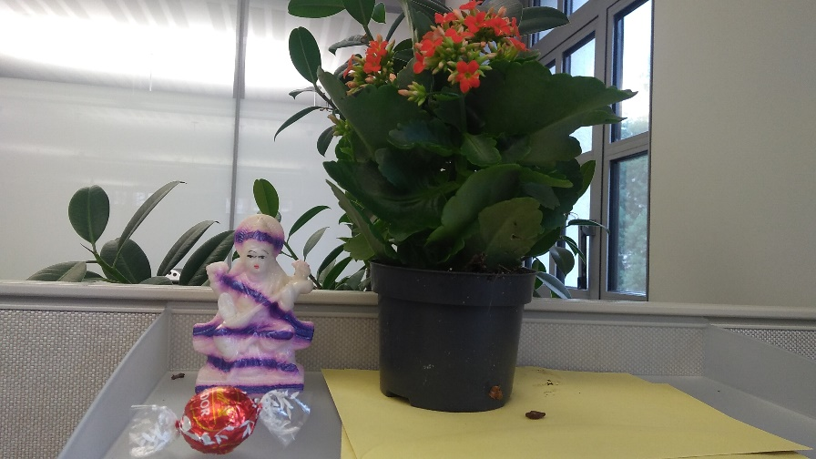

My li’l Saraswati, at my desk, being offered Lindt (Suisse) Chocolate.

Thanks to Bollywood, we all have the notion that every bad guy’s money is safely guarded in some Swiss Bank. And that was all that I knew about the Swiss banks as well. There was a big branch of one of the biggest Suisse banks near the main train station, so I just went there to open my bank account. Without the bank account I would not receive my fellowship, and was really afraid to be left without a single penny, very soon.

Here I must tell you, Geneva always holds its rank on top five contenders for the world’s costliest cities!! Anyways, let’s return to the Suisse bank. It took me 3 days and on an average 3 hours each day and piles of documentation and hundreds of places where they wanted my autograph (yeah my signature of course), and more than a week to ultimately open my bank account.

This should make you realize that the bureaucracy and the knot of red tape is the same everywhere. So why do we always curse our own system!! Can you believe, the Suisse banks never communicate over email or telephone? They will always send you a letter, written on a paper, delivered by the Suisse postal service. Oh my God, they still do these stuff!! I was wondering about our Indian postal service, it is almost functioning as the “appendix” to India’s anatomy (Thanks to our ‘digital’ era). Huhh!!

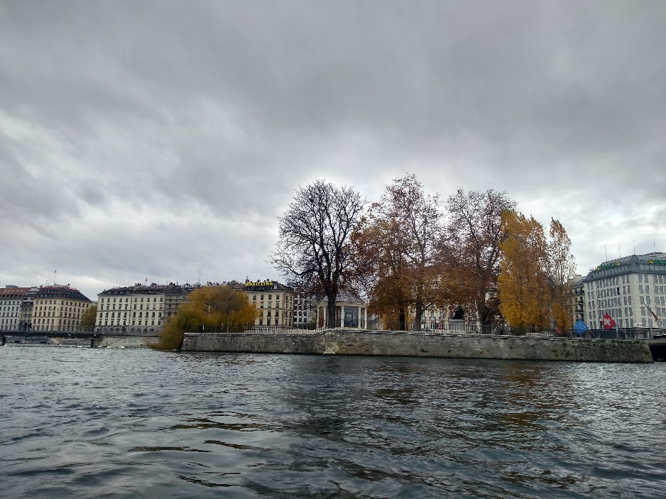

Colors of autumn, Lac Leman, Geneva, Switzerland

On some feel good note, when you come out of your country only then you introduce yourself as an Indian. So at last, I am an Indian. My current workplace is incredibly multi-national and multi-cultural. Here, I have colleagues from France, Italy, Spain, Russia, Iran, India, Japan, Bangladesh, Korea, Germany and the list goes on. Everybody has their own identity and style. Here nobody judges you for anything. Even if you wear a short skirt or a hijab, nobody stares at you. You can be yourself.

Lots of more apprehensions left to pen down. Let me continue that, in my next pieces of writing expressions.

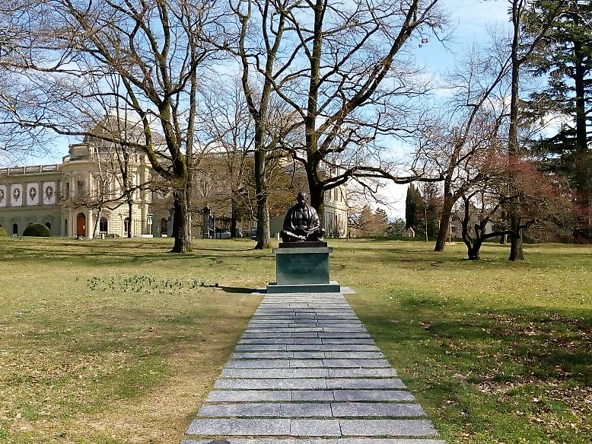

Gandhi ji, dwelling peacefully at a park near United Nations, Geneva, Switzerland

***To be continued….***